Implementation Model

# 

# Table of Contents

**Table of Contents** **1**

**Build Instructions (REVISED)** **1**

**Instances of Grasp Patterns (REVISED)** **2**

# 

# 

# 

# 

# 

# 

# 

# 

# 

# 

# 

# 

# 

# 

# 

# 

# 

# 

# 

# Build Instructions (REVISED)

To run our program in Linux, perform the following steps:

1) Download and put our files into a single directory (UI/Domain/Technical Services, as well as the script file)

2) open a console window, and type in "chmod u+x script.sh"

3) type "./script.sh"

4) Play the game!

To run in Windows:

1. Put the source code into visual studios and compile, maintaining the package structure

# 

# 

# 

# 

# 

# 

# Instances of Grasp Patterns (REVISED)

These are commented above the class declaration, but I have added a list here for ease of reading.

* High Cohesion/Low Coupling [simpleplayer class]
* Information Expert [simplegame class]
* Controller [simplegame class]
* Creator [simplegame class]
* Polymorphism [House, Bridge, Skyscraper, and School Classes]
* Factory/Protected Variation [ ScoreFactory and LocalScore Factory]

**File Structure (REVISED)**

Our file structure follows the package diagram shown below:

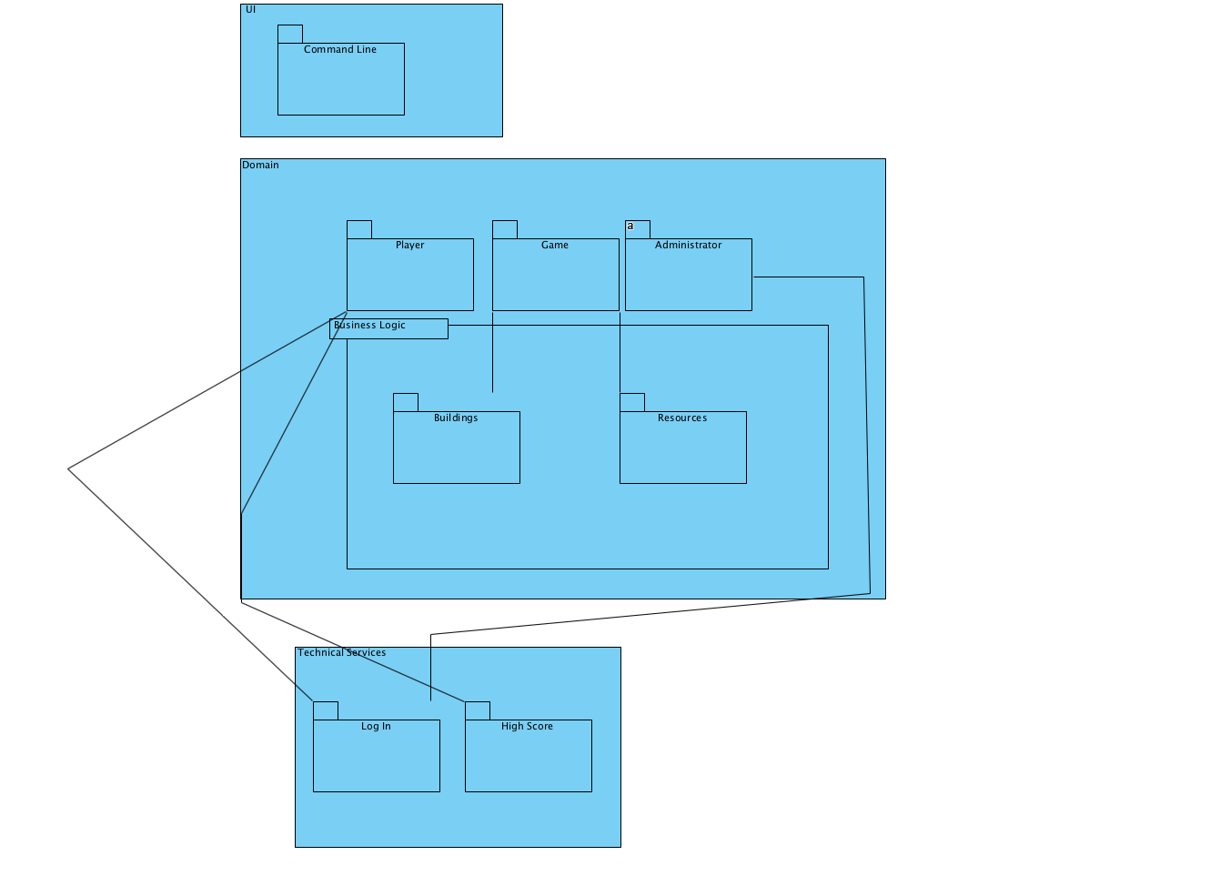

* UI (N/A) [essentially our main.cpp performs a similar function to a UI]
* Domain
  + Player
    - Contains the player interface and simple player class (player.hpp)
  + Game
    - Contains game interface and simple game class (game.hpp)
  + BusinessLogic
    - Contains building interface and the skyscraper, house, school, and bridge classes (building.hpp)
    - Also contains the resource interface and the simple resource class (resource.hpp)
* Technical Services
  + Login
    - Contains the login interface and simpleLogin class (login.hpp)
  + HighScore
    - Contains the highscore interface, LocalScore Factory, ScoreFactory, and LocalHighScore class (highscore.hpp)

|  |  |  |
| --- | --- | --- |
| Date | Phase | Info |
|  |  |  |
| 10/29/18 | Elaboration 1 | Initial Implementation model |
| 12/08/18 | Elaboration 2 | Updated Build Instructions, instances of Grasp Patterns. Updated package diagram so business logic goes in Domain layer and update to add High score interface. |